**Team 9 - College Major Financial Advisor**

**Project Proposal and Plan**

1. Introduction Describe in one or two paragraph the idea of and motivation for the project.
   1. **Project Overview:** The goal of this project would be to determine the average annual pay each college major would net students after they graduate college, and relay this information to upcoming, returning, or current college students for them to be informed on whether or not their major of choice is worth the price.
      1. **Statement of Proposal:** We propose to help people and college students learn about the costs and benefits of getting a degree and avoid potential debt after graduation.
   2. **Project Scope and Objectives:** The primary aspect of the project would be to display every college major available and its corresponding average annual pay. Another aspect that could be implemented into this project would be a list of potential jobs attainable with each major. A concentration and course list could be added as well so users can see the specifics needed to obtain their chosen degree. I could also see adding an average debt to each corresponding major. Ideal users of this data would be anyone who has an interest in college whether it’s returning, upcoming, or current students. Societally wise this project would ideally help people to stay out of debt, as many individuals who go through college go into debt through loans, this dataset could help students navigate majors that would allow them to escape debt in an easier fashion.
2. **Plan** This section contains a list of tasks and deliverables associated with the project, a Gantt chart depicting task durations, dependencies and completion dates, and a summary of resource requirements and assignments for each task.
   1. **Timeline Chart**

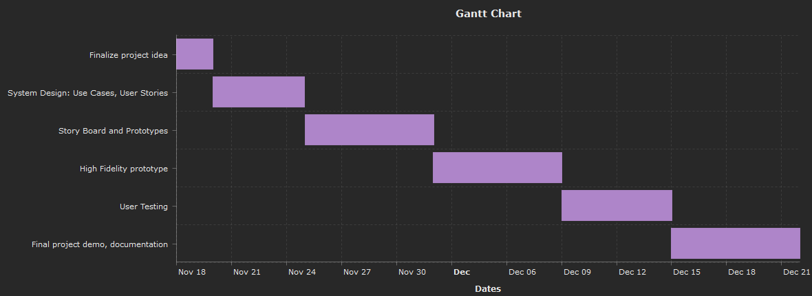

* 1. **Task Description**
     1. Finalize Project Idea
     2. Create User Stories
     3. Create Use Cases
     4. Create Storyboard
     5. Implementation of prototype
     6. Initial Testing
     7. Implementation of high fidelity prototype
     8. User testing on HF prototype
     9. Documentation
     10. Final Project Demo
  2. **Resource Table**

|  |  |  |  |
| --- | --- | --- | --- |
| **Task** | **People** | **Hardware**  **/Software** | **Special** |
| Finalize Project Idea | Alan, Eyup, Chase, and Jordan | Google Docs |  |
| Create User Stories | Alan, Eyup, Chase, and Jordan | Google Docs |  |
| Create Use Cases | Alan and Eyup | Lucidchart |  |
| Create Storyboard | Chase and Jordan | Trello |  |
| Implement prototype | Alan, Eyup, Chase, and Jordan | Juypter  Excel/MySQL | Kaggle |
| Initial Testing | Alan and Eyup | Anaconda |  |
| Implement high fidelity prototype | Alan, Eyup, Chase, and Jordan | Juypter  Excel/MySQL | Kaggle |
| User testing on HF Prototype | Chase and Jordan | Anaconda |  |
| Documentation | Jordan | Word/Google Docs |  |
| Final Project Demo | Alan, Eyup, Chase, and Jordan | Zoom/Webex |  |

1. **Project Resources**
   1. **Group Members**
      1. Alan Zhang
      2. Chase Brock
      3. Eyup Agirtmis
      4. Jordan Schrodt
   2. **Hardware and Software Resources Indicate the anticipated software and hardware resources required to complete the project.**
      1. Anaconda
      2. Jupyter notebook
      3. Excel/Sql
      4. Computer
      5. Lucid Chart
      6. Google Docs
   3. **Special Resources List any special resources needed to complete the project.**
      1. Kaggle
      2. <https://www.kaggle.com/dbsimpson/us-college-graduates-wages?select=labor_market_college_grads.csv>
2. **Appendices**

**N/A**